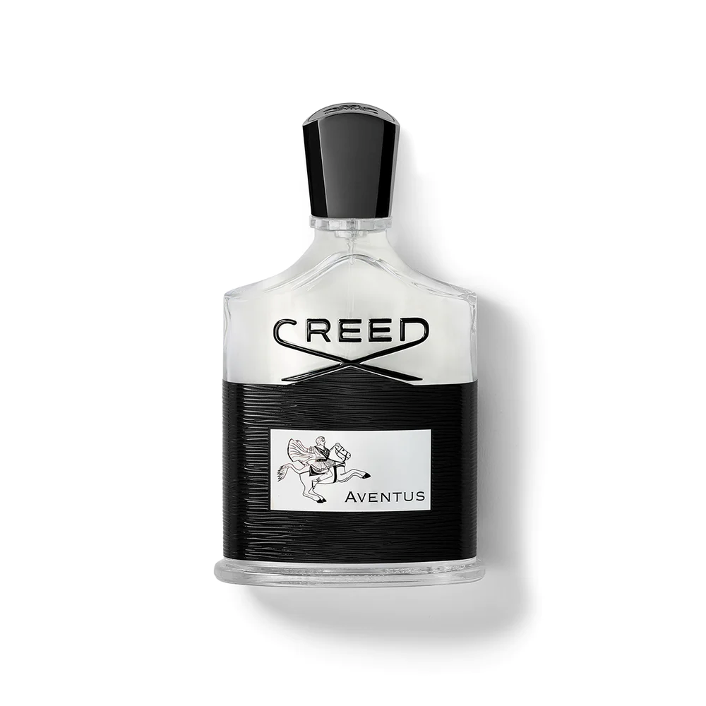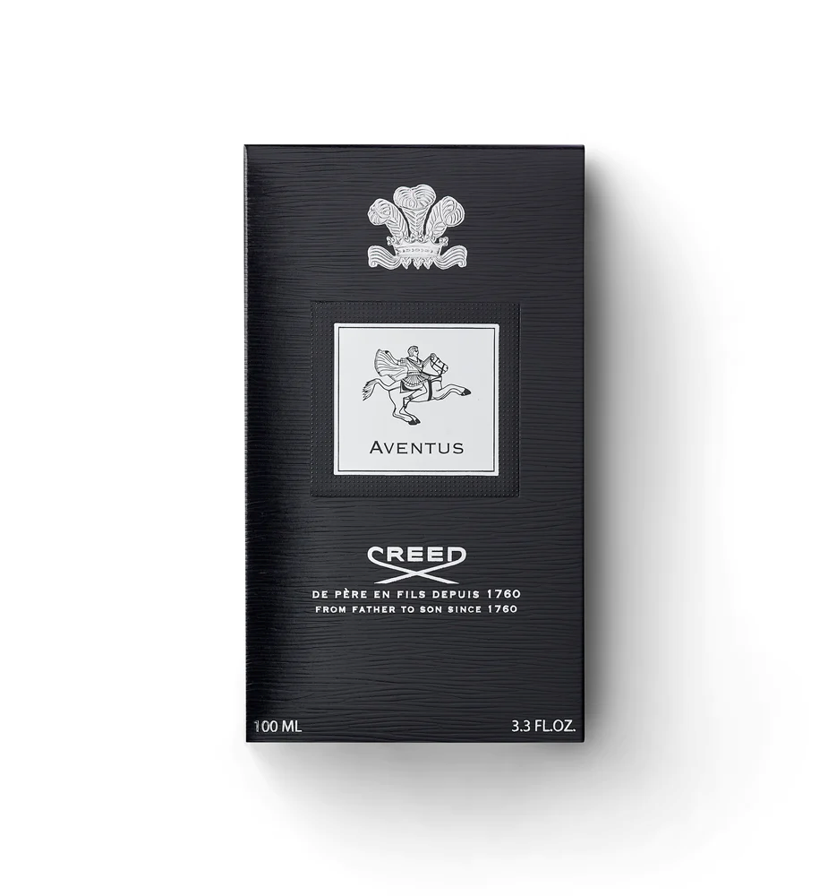

CREED AVENTUS

**$495.00**

Tax Included.

Spray 100 mL

IN STOCK

### Product Details

The exceptional Aventus was inspired by the dramatic life of a historic emperor, celebrating strength, power, and success. Introduced in 2010, this scent has grown to become the best-selling fragrance in the history of the brand.

Olivier Creed created its iconic name derived from a ("from") ventus ("the wind"), illustrating the Aventus man as destined to live a driven life